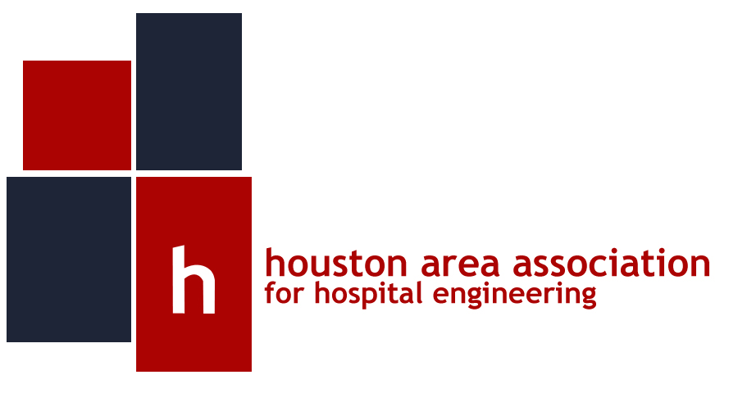

HAAHE Presents:
Heat Pumps and Heat Recovery for Healthcare Applications

Bill Chalmers P.E., CEM, CPD, CDT

January 8th at 11:30 AM – 12:45 PM
Crowne Plaza, Reliant Park/Medical Center
8686 Kirby Drive, Houston, TX 77054

Program:
At the November HAAHE Meeting, Dr. Zhu and Arnold Granger said that 37% of U.T. M. D. Anderson Cancer Center’s energy use is used for reheat. Hospitals also use large amounts of energy for domestic hot water heating.
Hospitals in Houston have constant cooling loads that are satisfied by refrigeration equipment that reject heat to the atmosphere. Substantial energy savings are available by using the rejected heat for reheat and domestic hot water heating.
Please plan to attend this presentation that provides Hospital facility managers the information associated with heat pumps and heat recovery applied to healthcare applications. Topics include:
- Why healthcare facilities require reheat
- Domestic hot water heating basics
- Refrigeration review
- Heat pump system
- Heat recovery system
- Desuperheaters
- Air to water heat pumps
- Applications issues

About the Speaker:

Bill Chalmers is a registered professional engineer with 30 years experience in the HVAC industry. He is on the board of HAAHE and the local ASHRAE Chapter. As vice president of engineering for Page/ Architects and Engineers, Bill was responsible for the design of many health care facilities including the Methodist West Houston Hospital.

andy’s educational background includes a Bachelor of

About the Organization:
HAAHE is a non-profit group organized specifically for the benefit of the Healthcare Facilities Management team. Membership is focused on Hospital Facilities and Safety Management staff. In addition, Engineering Consultants, Contractors, Vendors, and Architects whose primary function is to provide consulting, design services, and products to the hospital engineering environment are welcomed.
The purpose of HAAHE is to provide a forum for continued improvement of hospital engineering in the greater Houston area. The venue for improvement will be through education, sharing of experiences between members, and presentations by experts in their respective field on a bi-monthly basis. If you are already a HAAHE member, please get involved by attending our meetings every other month. If you are not yet a member, you may join by completing a membership application at the next meeting. Lunch is included and will be free for paid members and $15 for non-members.

For the Calendar year 2015, we are now accepting membership renewals. Membership fees will be:
Hospital employees: $50.00 annually
Vendors/Associates: $100.00 annually

Sponsorship:
Sponsorships are available for each luncheon session. For $300 per vendor, you will be allotted a single table space to display brochures and wares prior to the luncheon presenting, will be recognized on our website as a luncheon sponsor, and will be introduced prior to the session start. An exclusive sponsorship arrangement is available for $1,200. Please contact us at playegh@mdanderson.org with any questions or sponsor requests.

Location:
The Crowne Plaza Reliant Park/Medical Center is located at 8686 Kirby Drive, Houston, TX 77054. It is physically located at the northwest intersection of Loop 610 and Kirby Drive, across from Reliant Park. For directions:
http://maps.google.com/maps?f=q&source=s_q&hl=en&geocode=&q=8686+kirby+drive,+houston&sll=37.0625,95.677068&sspn=39.644047,92.900391&ie=UTF8&hq=&hnear=8686+Kirby+Dr,+Houston,+Harris,+Texas+77054&z=16

RSVP/Information:
Please RSVP at our new website www.HAAHE.org. For more information please feel free to contact us at avinson@victaulic.com or by phone at 281.900.0951.

